  

Customize the Game Celeste

Duration: 1 - 1.5 hours

This workshop starts with the popular game Celeste. Students will play and learn how to customize the look of the main character and background using the sprite and map editors.

This outline goes through how to change Celeste by using the Code, Sprite and Map editors. Each of these can be thought of as a stand alone exercise that can be omitted or used on its own.

Introduction: 10 mins

Overview of PocketC.H.I.P. and Pico-8

Play Celeste: 10 minutes

Open Celeste

Play

Contest!

Edit Celeste: 30 - 50 minutes

Code editor

Sprite Editor

Map Editor

Reflect: 10 minutes

# 

# 

# Introduction: 10 mins

## Overview of PocketC.H.I.P. and Pico-8

What are we going to do?

* Play games!
* Change games!
  + edit character
  + edit map
  + edit code!

# Play Celeste: 10 minutes

## Open Celeste

* Open Pico-8. Walk through the tour with the students to get a feeling for the controls and what the workshop will outline.

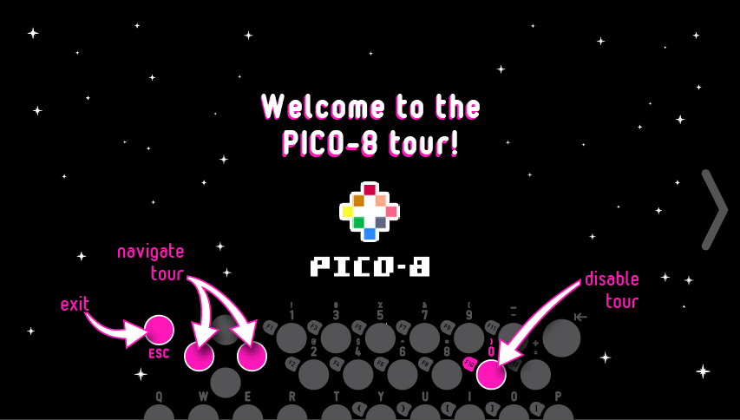

* When the tour ends, you will see the Pico-8 C.H.I.P. Edition title screen. Press “**0**” to **exit** and continue on to Pico-8.

* You will be taken to the ‘splore menu. Use the left and right of the D-pad to select “**Featured**”. Use the up and down to select **Celeste**.
* Press “**=**” twice to open Celeste.

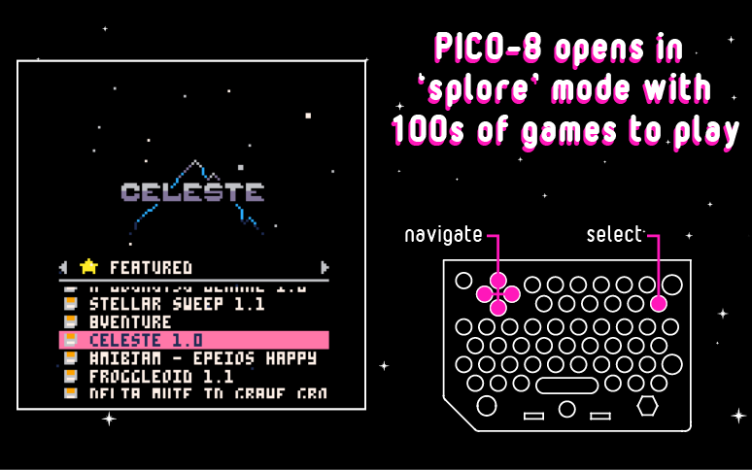

## Play

#### **Contest!**

* The students have **5 minutes** to get to the highest level of Celeste. Whoever gets to the highest level wins! It does not matter how many times they die.

Celeste Controls:

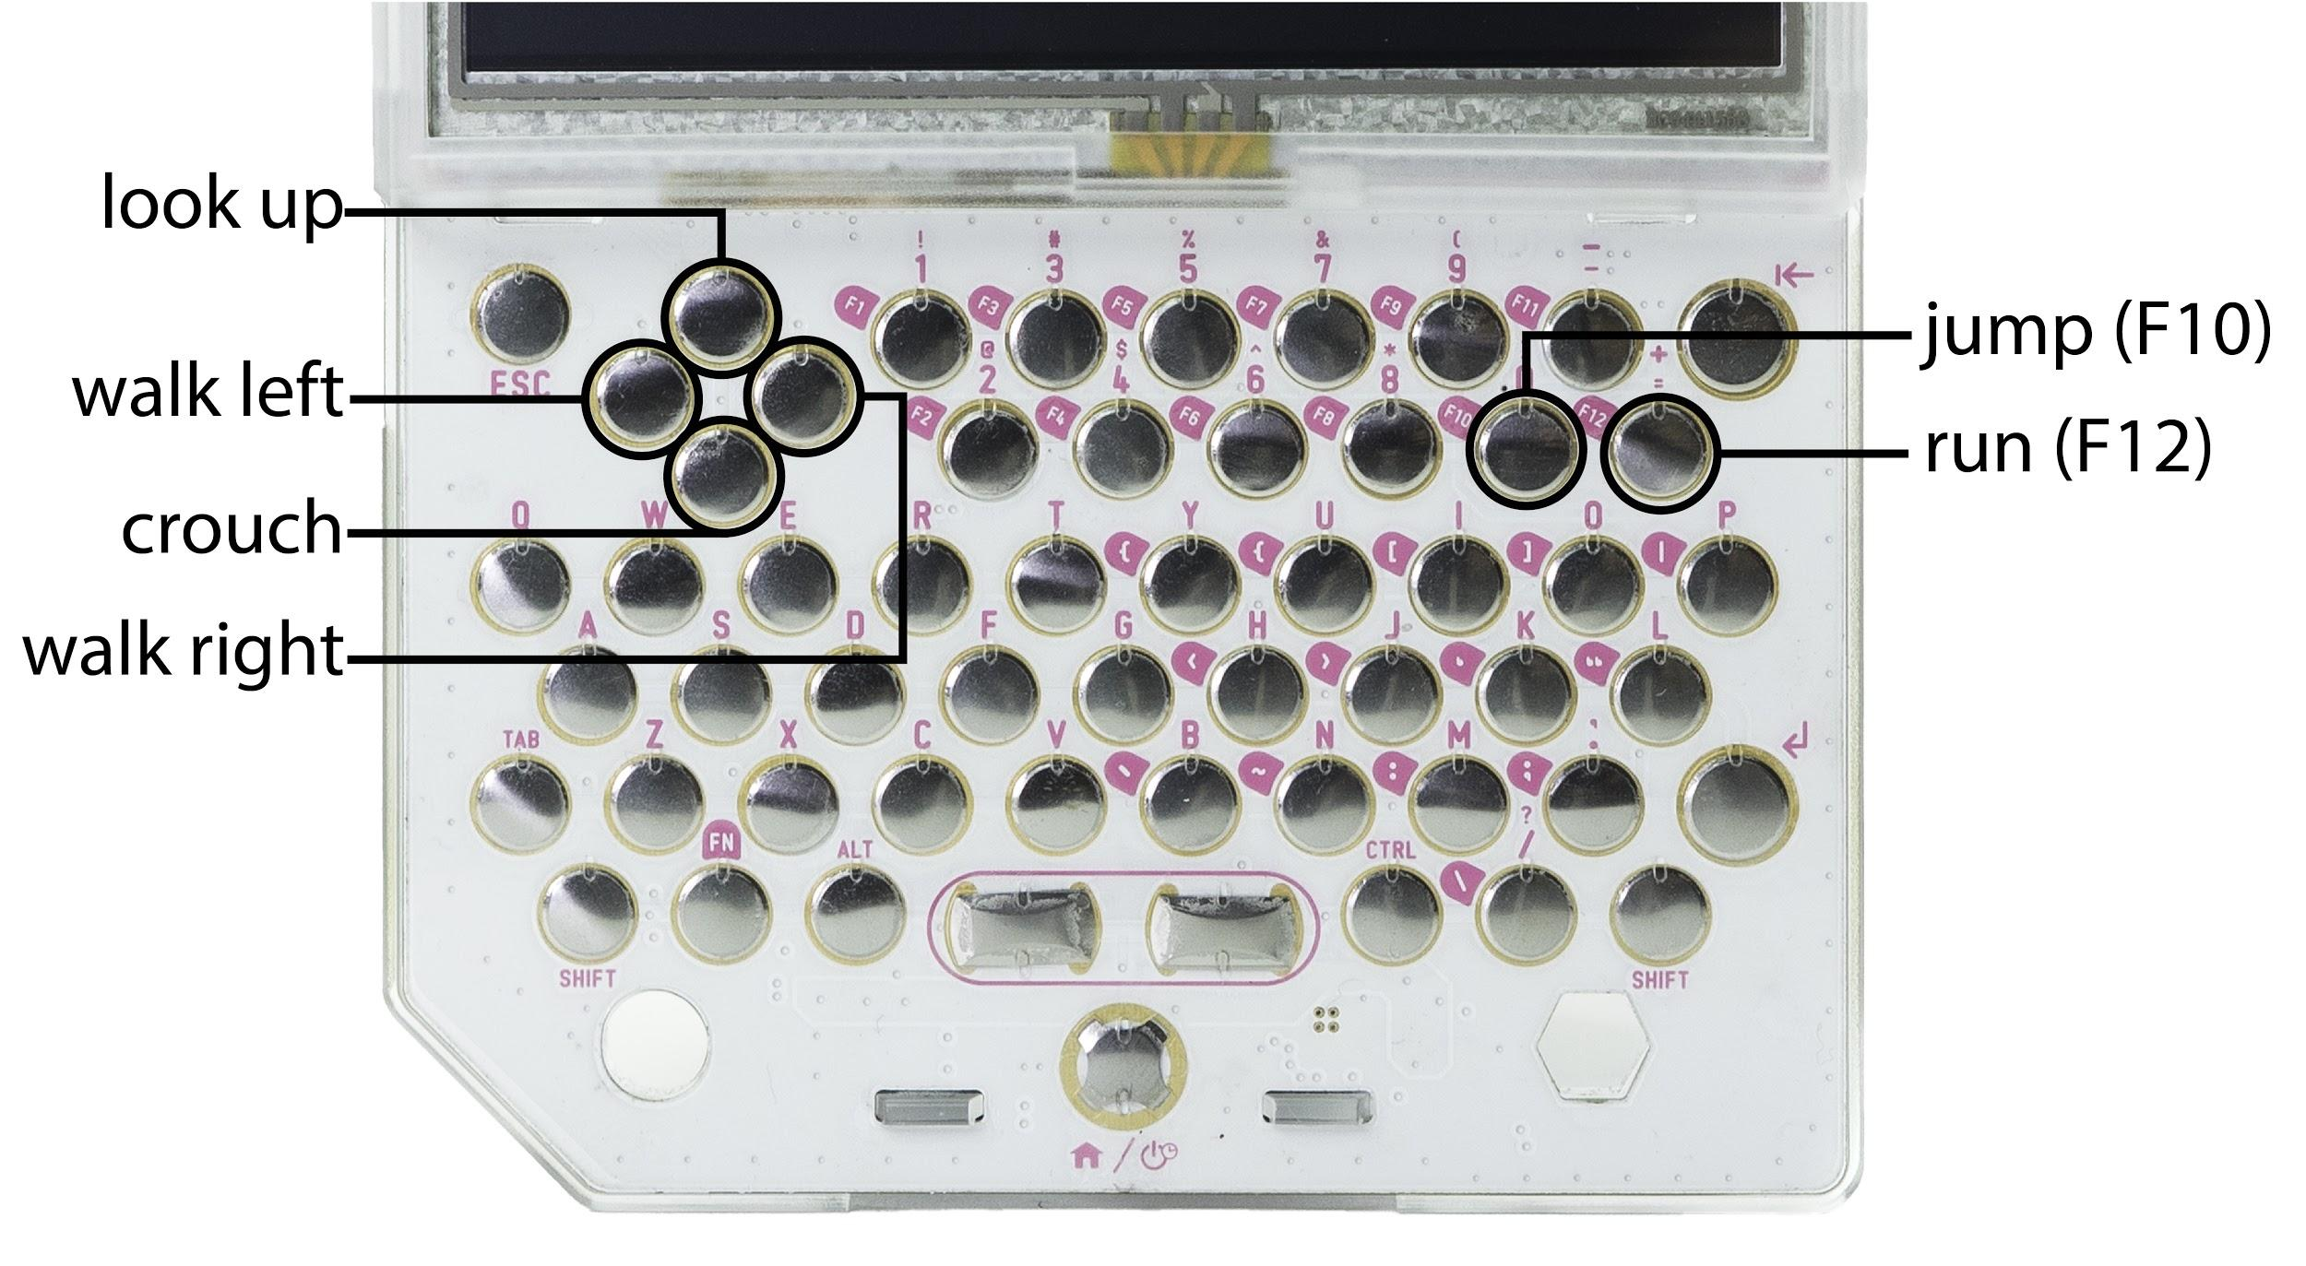

* Stop everyone: Raise you hand if you beat level 1...2...3..etc.
* The students will learn that Celeste is hard! By the end of the class everyone should have the knowledge to make Celeste easier and more fun.

# Edit Celeste: 30 - 50 minutes

## Code editor

* From the Map editor tap the Code editor icon.

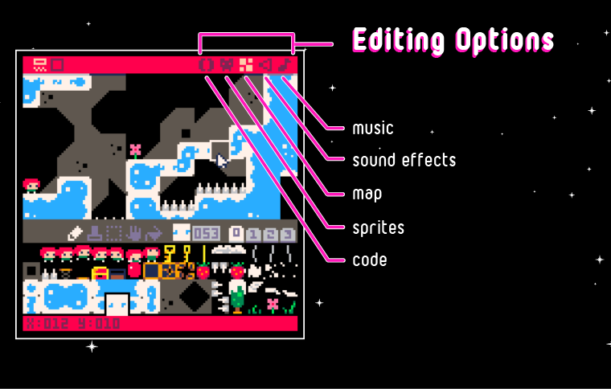

* All the changes made to the sprite and map are automatically updated in the code. Let’s now change the code to **effect the gravity of the game**. Physics! Can this also be a way to make it easier for Celeste to jump over large gaps like the one made a bridge for?
* Press **Ctrl+f** (for find) and search for the term “**gravity**”.

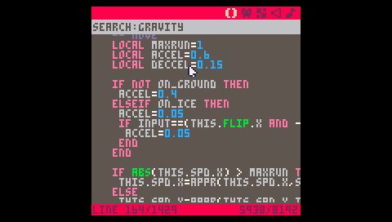

* Change the **local** variable called **GRAVITY** from **0.21** to **1**.

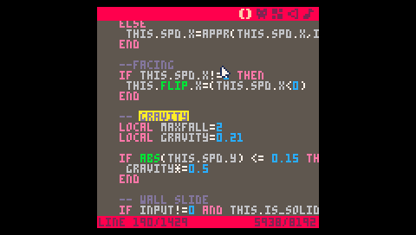

**Tip! Press Ctrl+Z** to undo and go back to the default code settings!

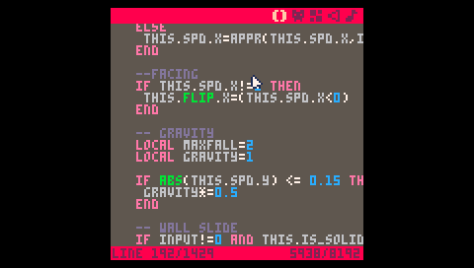

* Run the game with the new gravity value. **esc**, **RUN**, **enter**, “**=**”.
* Make Celeste jump (F10). Do you notice anything different? How would you make jumping easier for Celeste?

## Sprite Editor

* Time to edit the game! Let’s change the way the character looks. There are several editors in Pico-8 that allow you to edit the music, characters (called sprites in video game design speak) and the background.
* While playing Celeste press **ESC** and choose “**EDIT THIS CART**” and press **enter**.

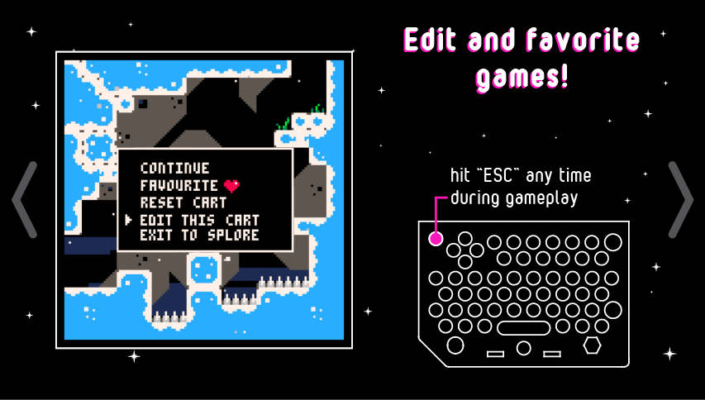

* You will be dropped into the code editor and will see all of Celeste’s source code.

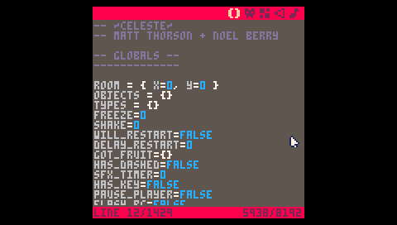

* Tap the Sprite Editor icon that looks like a face to the right of the () icon.

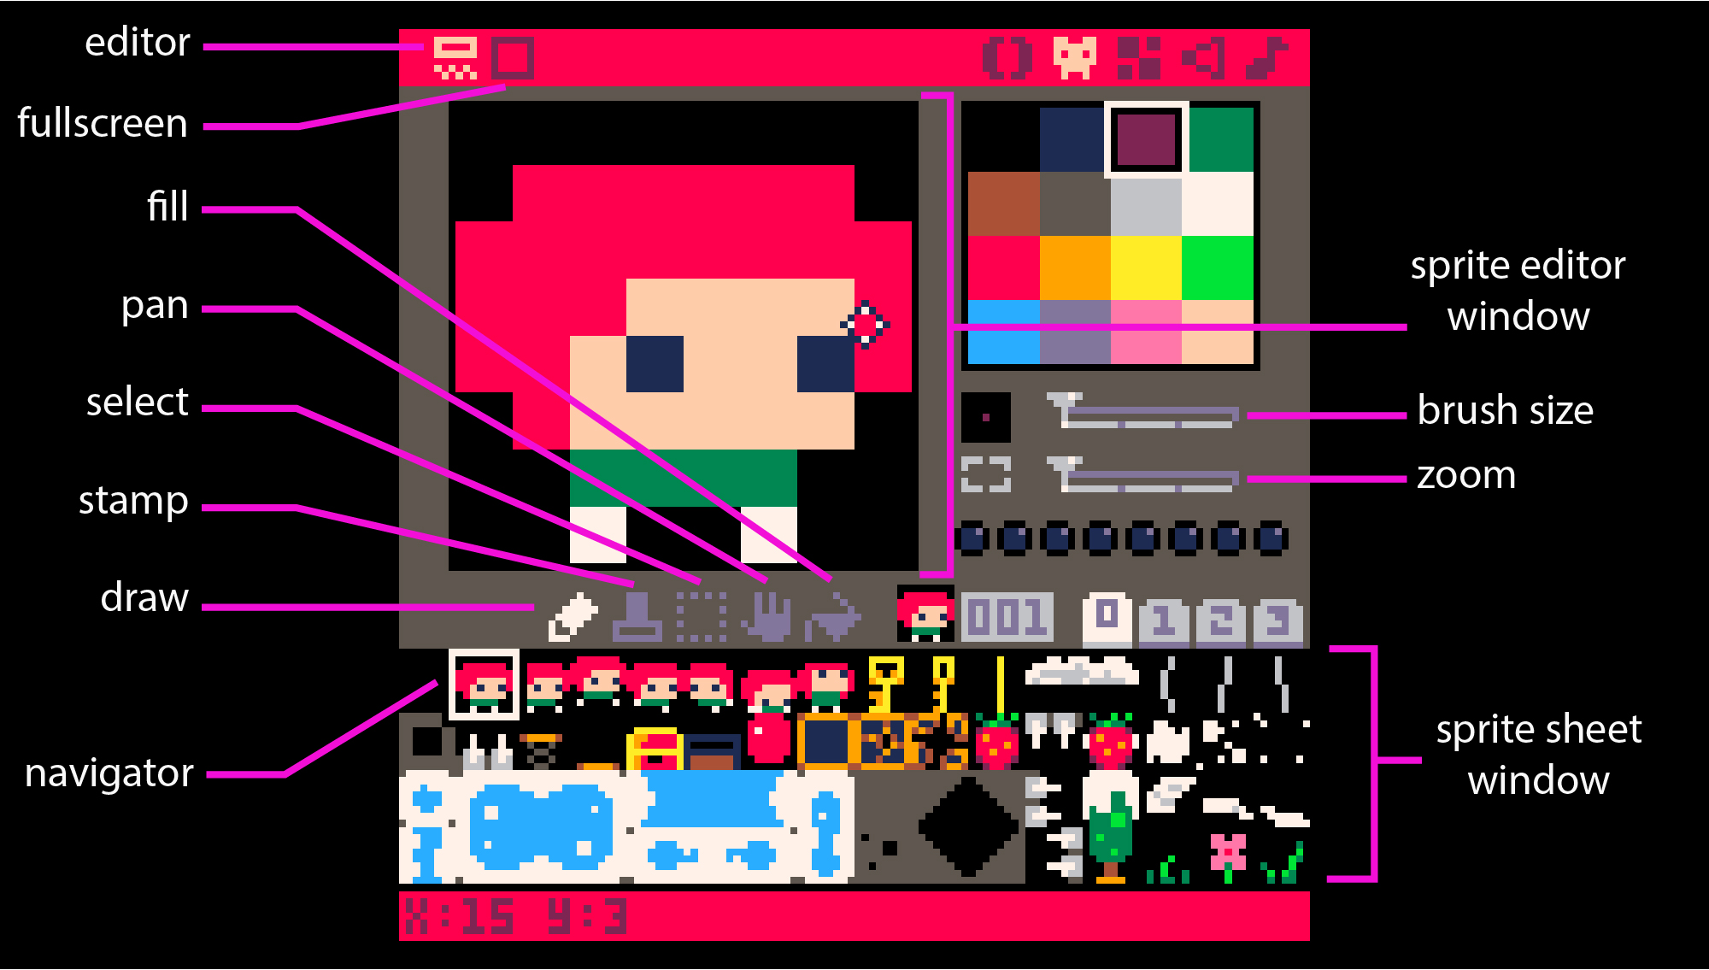

* Choose a color by tapping on one in the pallet.
* Make sure the Draw tool is selected and then tap Celeste’s hair to change the color.

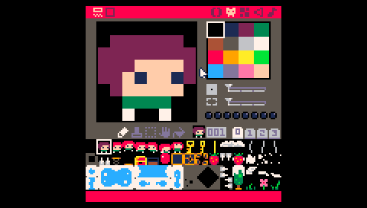

* Press **esc** to get to Pico-8’s console.
* Type **RUN** and press **enter** then “**=**” to play the game with the changes you made!
  + The first time you type **RUN** it will be in the a blank console.
  + The second time the console will have the background of the game. The action is the same, type **RUN**, **enter** then “**=**” to play the newly edited game.

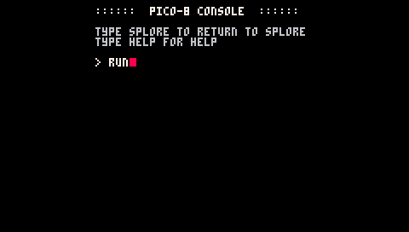

* Celeste will have a new hair color! Only one frame will have the new color though. This is because the animation is made up of the many Celeste’s in the sprite sheet.

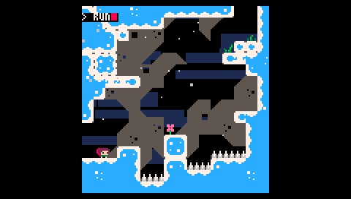

* From the Press **esc twice** to get back to the **Sprite Editor**

## Map Editor

Not only can you make Celeste easier by changing the code but you can rebuild her world too with the Map Editor.. The goal of this exercise is to bridge a large gap with block elements to form a bridge.

* From the Sprite Editor choose the Map Editor icon that is made up of 4 squares.



* Pan down the to the bottom of screen by selecting the **Pan tool** or by pressing the **spacebar** while **dragging**.

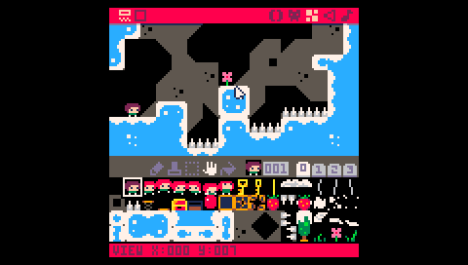

* Select a blue block element, select the Draw tool and create a bridge by tapping the screen.

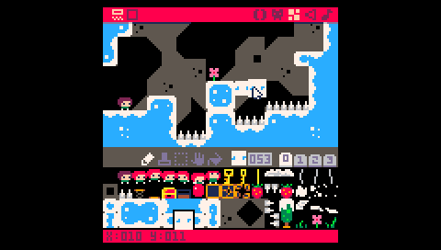

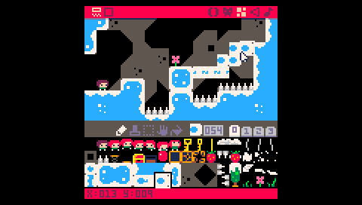

* Play the edited game!
* Can anyone remember how to run the new game?
* Press **esc** and type **RUN**, press **enter** then “**=**” to play new game.



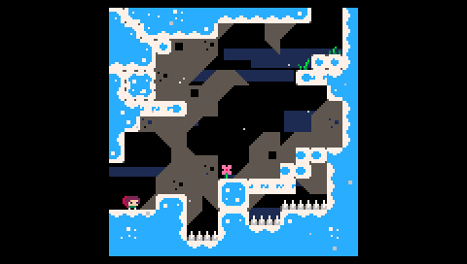

* You can now walk over that large gap rather jump all that way!
* How else would you edit the game?

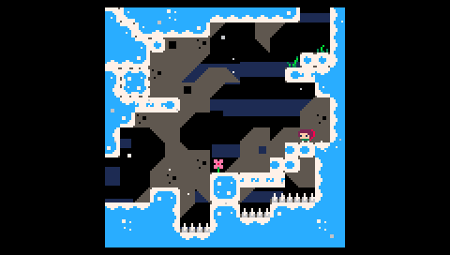

Apply these new skills to change more of the game. Feel free to explore and hack other games.

* **Get back to the ‘splore menu** by pressing **esc** to get to the console and typing “**splore**”.

# Reflect: 10 minutes

Discuss what was learned and how the students feel about coding and game design.

* What did we learn?
  + How to play games in Pico-8
  + How to change sprites
  + How to change maps
  + How to edit the game’s source code
* How did you feel about coding/game design before you played with PocketC.H.I.P. and Pico-8?
* How do you feel about coding/game design now that you have played with PocketC.H.I.P. and Pico-8?